Hey guys,

Its repeated measures time! This is one of the most commonly used methods to handle modeling strategies with correlated data. In a nutshell, the repeated measures concept and issues are exactly like that of time series, the differences being that instead of one experimental unit in time series we typically have a set of subjects all who have measures repeated over time.  So it’s kind of like we have multiple time series.  The other big difference is that we usually don’t have a lot of data.

The videos and book introduce repeated measures from a multivariate analysis perspective. Although correct, it does convolute two particular issues together and we will get into that a little later this semester.  Understanding the basic multivariate concepts is important and we will be using them later too, so the first part of live session next week I will be going over the key things you need to understand from a multivariate concept. So I’ll be answering things like “what the heck is a covariance matrix?”.

Like time series, repeated measures can crop up in any type of general regression problem.  What we will focus on in the assignment is the monkey data through the videos.  Similar to what Dr. McGee has already done, the key thing to understanding about what repeated measures can do for you is comparing it to results when you ignore that they are repeated measures. We are going to compare an analysis of this data by treating it like a simple 2way anova problem and compare it with a repeated measures type analysis.  So here are the following tasks for next week.

In the SAS code you will find code to read in the data and run two different two way anova models.  Before you get going,  I want you to change the response variable from the “Percent” variable to the “NewPercent”.  I have fudged the data a little to help make the points more clear. I want you to answer the following questions.

1. (Optional) This would be a good time to just practice a full blown analysis of a two way anova model.  Research the data a little, come up with some key questions, and try it out.

Chose to go fishing instead.

1. Compare the type-3 sums of square anova table (from the GLM model ) with that from the type3 table for fixed effects using the other model (repeated measures).  What if anything has changed in terms of testing and the actual F values and pvalues?

GLM:

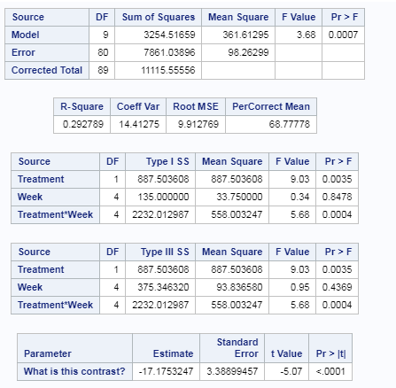

Type 3 p-values show that treatment and treatment\*week are significant, but week alone is not significant to the model with p-value of .4369.

Repeated Measure:

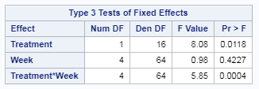

For the repeated measure, it looks like treatment is less significant than the glm and week is more significant along while the interaction stayed the same.

1. Based on what you know about 2way anova, is there an interaction?  Also, to get at one of the researchers questions, figure out the contrast that would test for the difference in mean percentage between Treated and Control groups specifically for Week2.

Yes, there is an interaction given that the interaction tem has a p-value of .0004 which is significant.

The contrast would be the following:

estimate 'What is this contrast?'

proc mixed data=monkey;

class Treatment Memory Monkey Week;

model PerCorrect=Treatment Week Treatment\*Week;

repeated Week/ type=CS subject=Monkey;

lsmeans Treatment\*Week / pdiff tdiff adjust=Tukey;

estimate 'What is this contrast?' Treatment -1 1 Treatment\*Week -1 0 0 0 0 1 0 0 0 0;

run;

1. Can you also write a contrast to test for Week 12 vs Week2 for the Treated group?  Include the contrast in both of the procs and compare the result.  Are they the same, if not what is different?

GLM

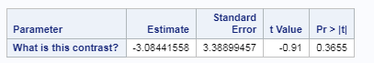

Repeated Measure:

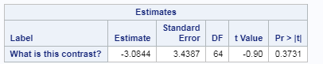

T-val and p-value are almost the same. Looks like estimate and standard error may have a rounding difference between the two procs.

1. I have added an additional contrast already in the code.  Can you tell me what it is testing for? Hint:  It is related to the key question discussed about this data set from the videos and the text.

It is comparing the control vs treated for the 2nd and 4th week.

I have also attached a very handy paper that discusses longitudinal repeated measures analysis and shows the differences between using GLM compared to MIXED (which I like more and is easier and more flexible).  I’ll give you my reasons during live session.